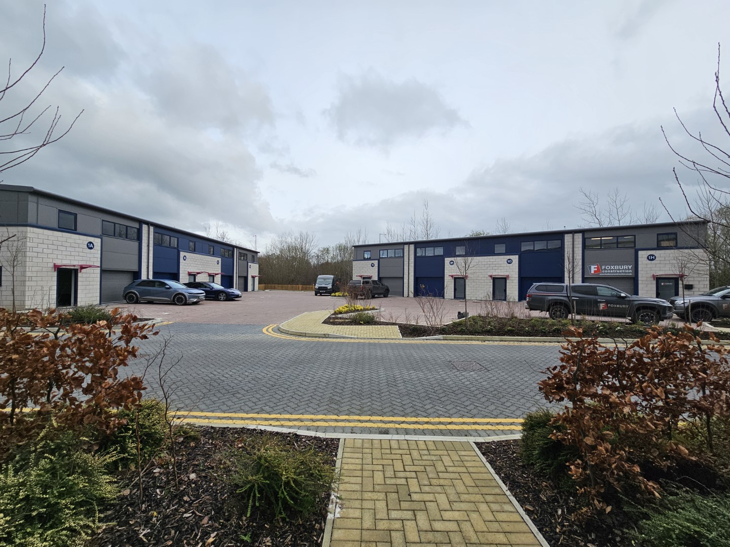
Business Units / Industrial / Offices
TO LET/ FOR SALE
Precision 2 Industrial Estate, (Phase II)
Bingham Road, Eurolink 4, Sittingbourne, Kent, ME10 3TR

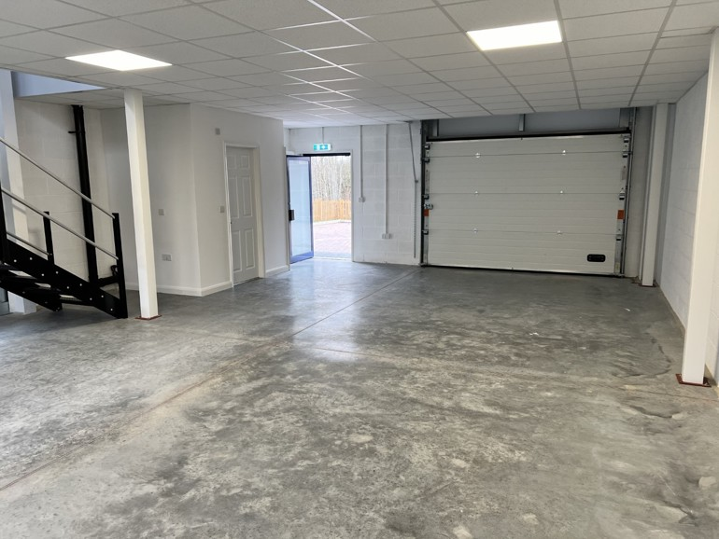
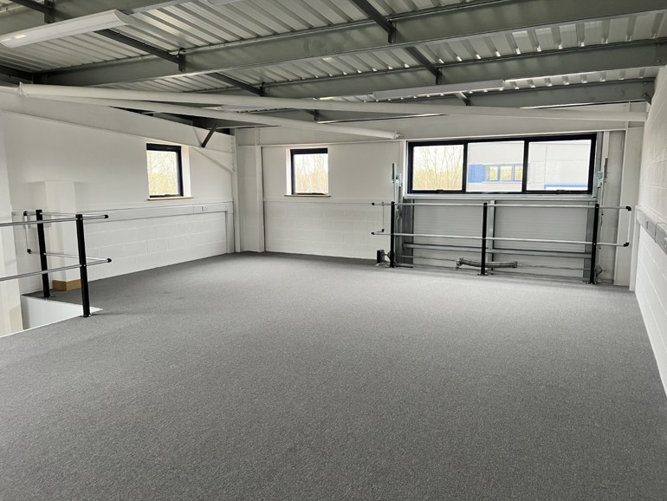

Precision 2 Industrial Estate, (Phase II)
Bingham Road, Eurolink 4, Sittingbourne, Kent, ME10 3TR

Key Features
 | New Build Units |  |  | Rent From £12.50 per sq ft or For sale from £300,000
 | New Leases Available |  |  | EPC - 'B'
 | Units From 759 sq ft |  |  | LED Lighting

Description
NEW BUILD BUSINESS / INDUSTRIAL UNITS - TO LET

This development is the second phase of the successful Precision 2 Business Park Estate and provides new two storey business units from 759 sq ft over the two floors and will provide 8 units in total.

The units are constructed of a steel portal frame with insulated steel cladding and roofs, each benefiting from a loading door and a separate personnel door. Each unit will have ground floor storage/workshop area, WC, kitchenette and first floor open plan office/storage space with suspended ceiling, LED lighting and perimeter trunking.

Each unit has allocated car parking spaces.

Accommodation
The units are constructed of a steel portal frame with insulated steel cladding and roofs, each benefiting from a loading door and a separate personnel door. Each unit will have ground floor storage/workshop area, WC, kitchenette and first floor open plan office/storage space with suspended ceiling, LED lighting and perimeter trunking.
The properties have been measured on a Gross Internal Area (GIA) basis as follows:

Area | Ground Floor Sq Ft | First Floor Sq Ft | Total  Sq Ft | Total  Sq M | Availability | Rateable Value
Unit 1A | 759 | 759 | 1,518 | 141.02 | UNDER OFFER | £21,000
Unit 1B | 759 | 0 | 759 | 70.5 | SOLD STC | £21,000
Unit 1C | 759 | 0 | 759 | 70.5 | Available | £21,000
Unit 1D | 759 | 759 | 1,518 | 141.02 | LET | £21,000
Unit 1E | 705 | 705 | 1,410 | 130.99 | LET | £19,500
Unit 1F | 700 | 0 | 700 | 65.08 | SOLD | £19,500
Unit 1G | 700 | 0 | 700 | 65.08 | SOLD STC | £19,500
Unit 1H | 700 | 700 | 1,400 | 130.06 | LET | £19,500
Total |  |  | 8,764 | 814.25

Rateable Value
See table above.

Legal Costs
Each side to bear its own legal and professional costs

Rent
Unit | Rent £ pa exclusive | Unit | Rent £ pa exclusive
Unit 1A | UNDER OFFER | Unit 1E | LET
Unit 1B | SOLD STC | Unit 1F | SOLD
Unit 1C | £15,000 pa | Unit 1G | SOLD STC
Unit 1D | LET | Unit 1H | LET

Terms
The premises are immediately available by way of a new full repairing and insuring lease for a term to be agreed by negotiation and subject to upward only rent reviews to market rent

Service Charge to cover the upkeep and maintenance of the common estate.

VAT
Unless otherwise stated, all rents/prices are quoted exclusive of Value Added Tax (VAT) which will be charged at the prevailing rate. Prospective occupiers should satisfy themselves as to any VAT payable in respect of any transaction.

EPC
Each unit has a Rating of ''B'' with scores from 26 - 32

Precision 2 Industrial Estate, (Phase II)
Bingham Road, Eurolink 4, Sittingbourne, Kent, ME10 3TR

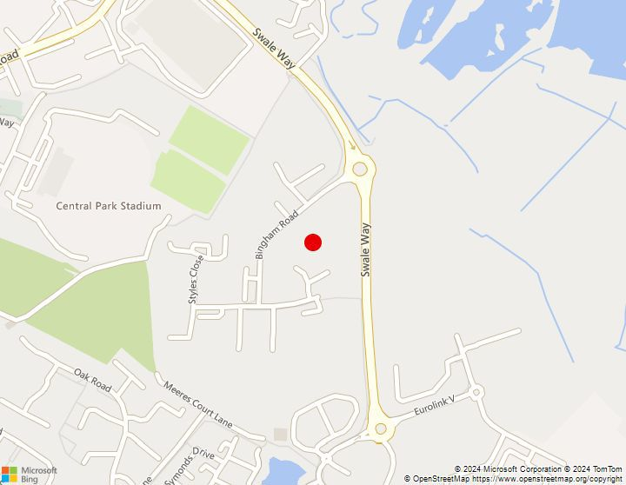
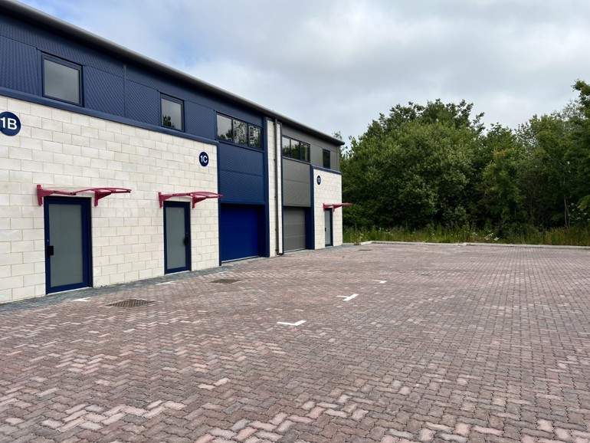
AGENCY & iNVESTMENT | lEASE aDVISORY | pROPERTY vALUATION | pROPERTY mANAGEMENT | bUILDING SuRVEYING
Sibley Pares Chartered Surveyors is a trading name of Sibley Pares LLP Registered in England and Wales No: OC400776 Registered Office: 1 Ashford Road, Maidstone, Kent ME14 5BJ VAT Registration No. 218 5130 30
Precision 2 Industrial Estate, (Phase II)
Bingham Road, Eurolink 4, Sittingbourne, Kent, ME10 3TR

Location
The development is situated in a prominent location at the junction of Swale Way and Bingham Road on the highly successful Eurolink Business Park which has benefitted from the opening of the A249 distribution road providing direct access to the M2, M20, Sheerness Port and the national motorway network. Sittingbourne mainline train station and town centre is within 1 mile of the Estate.

What3words Location:- https://w3w.co/dent.courier.poem

Drive Time | Miles | Mins
Canterbury | 16.5 | 30
Maidstone | 14.2 | 23
M25, J1a (Dartford Crossing) | 31.0 | 30

For all Viewings and Enquiries contact:
 | Phil Hubbard  phil.hubbard@sibleypares.co.uk |  | 
 | Dominic Barber  Dominic.barber@sibleypares.co.uk

NOTE: Rental prices or any other charges are exclusive of VAT unless otherwise stated. MISREPRESENTATION ACT 1967. These particulars are believed to be correct, their accuracy cannot be guaranteed and are expressly excluded from any other contract. Any intending purchaser must satisfy himself by inspection or otherwise as to the correctness of each of the statements contained in these particulars. No fittings, appliances or services mentioned have been tested by Sibley Pares.

